**The Journal of Computing For Professionals**

**(CFP) EER Database**

By:

**Samuel Wong, Hannah Jones,**

**Jeel Patel, William Fletcher**

Submitted to:

**Dr. Hashemi**

As

**Assignment #3**

for

**Database Systems**

**May 1, 2021**

Contributions

|  |  |  |  |
| --- | --- | --- | --- |
| **Name:** | **Tasks:** | **Contribution Percentage:** | **Signature:** |
| Jeel Patel |  |  |  |
| Hannah Jones |  |  |  |
| William Fletcher |  |  |  |
| Sam Wong |  |  |  |

Percentage is based on time logged, value of contribution, and correctness of contributions by our estimation. We do not believe this is a perfect representation, but that it is relatively accurate to the assigned tasks.

**Table of Contents**

|  |  |
| --- | --- |
| **Subject** | **Page #** |

1. Introduction 1
2. Blocking 2
3. Block to EER Conversions 3
4. Table of Attributes 11
5. EER Diagram 14
6. Relational Schema 15
7. Appendix 16

**Table of Figures**

|  |  |
| --- | --- |
| **Table of Figures** | **Page #** |

Figure 1: Journal EER Diagram 3

Figure 2: Article EER Diagram 4

Figure 3: Reference EER Diagram 5

Figure 4: Event EER Diagram 6

Figure 5: Conference EER Diagram 7

Figure 6: Conference Member EER Diagram 8

Figure 7: Job Listing EER Diagram 9

Figure 8: Student Profile EER Diagram 10

Figure 9: Complete EER Diagram 14

**Table of Tables**

|  |  |
| --- | --- |
| **Table of Tables** | **Page #** |

Table 1: Table of Attributes ……………………………………………………………………. 11

# Introduction

The Journal of Computing for Professionals authorities have contacted our team of database design consultants and requested that we deliver an Enhanced Entity Relationship (EER) database model based on their journal. To accomplish this, we started by using semantic rules that were previously collected for our Universal Relation design and converted them into blocks using the entities we had identified in the semantic rules. We took all the semantic rules with information about one entity and put them in a new block along with the entity’s relationships with other entities, repeating this for each entity. Following this, we systematically converted our blocks into a single EER diagram. Then we converted the diagram into a relational schema using the algorithm given to us in class. This report contains a detailed explanation of each step in this process.

# Blocking

1. A journal has a volume number, issue number, and issue date. A Journal publishes several Articles, announces several Events, advertises several Job Listings, and highlights several Student Profiles.
2. An Article has a unique ID number, a title, abstract, content, several keywords, and several authors. An Article Author has a name, employer, and affiliation. An Article cites several References.
3. A Reference has a unique ID number, a title, page index, release date, location, source, and several author names.
4. An Event has a unique ID number, a start date, end date, location, name, point of contact, and several sponsors. An event can be a Conference. A Point of Contact has a name, address, email, fax number, and telephone number.
5. A Conference is a type of event, and has a coordinator, several guidelines, several topics of interest, several conference paper submission dates, and several sets of paper contact information. Conference paper submission dates have a type and a calendar date A paper contact information has name, type, address, email, fax number, and telephone number. A Conference is attended by several Conference Members.
6. A Conference Member has a unique ID number, a name, type, affiliation, and country.
7. A Job Listing has a unique ID number, an open date, close date, title, description, salary, status, location, employer, set of contact information, and several qualifications. A Job Contact Information has a name, address, email, phone number, and fax number.
8. A Student Profile has an ID, name, city, state, country, backstory, and several degrees. A Degree has a degree level, completion year, and degree type.

## Block to EER Conversions

For each block:

1. Name of the entity
2. The nature of the entity (i.e., superclass, subclass, regular, or weak entity)
3. Name(s) of the entity’s superclass(es), if applicable
4. Name(s) of the entity’s subclass(es), if applicable
5. Entity attributes
6. Entity relationship(s) with other entities, if applicable

Block 1:

1. Journal
2. Regular Entity
3. No Superclasses
4. No Subclasses
5. A journal has a volume number (VolNum), issue number (IssNum), and issue date (IssDate).
6. 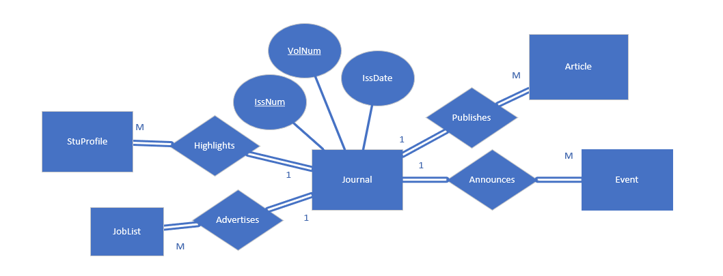A Journal publishes several Articles, announces several Events, advertises several Job Listings, and highlights several Student Profiles.

Figure 1: Journal EER Diagram

Block 2:

1. Article
2. Regular Entity
3. No Superclasses
4. No Subclasses
5. Article has a unique ID number (ArticleID), a title (ArticleTite), abstract (ArticleAbstract), content (ArticleContent), several keywords (ArticleKeyword), and several Article Authors (ArticleAuthor). An ArticleAuthor has a name (ArticleAuthorName), an employer (ArticleAuthorEmployer), and an affiliation(ArticleAuthorAff).
6. 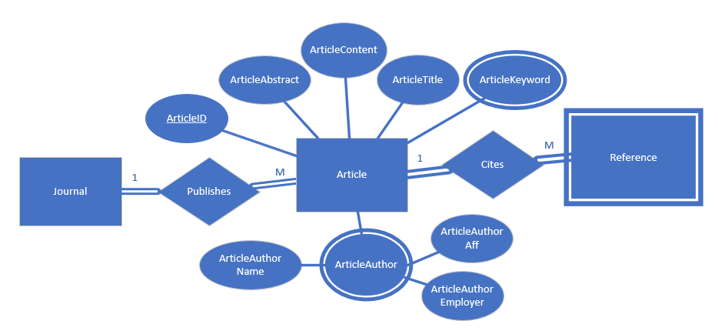A Journal publishes several Articles. An Article cites several References.

Figure 2: Article EER Diagram

Block 3:

1. Reference
2. Weak Entity
3. No Superclasses
4. No Subclasses
5. A Reference has a unique ID number (RefID), a title (RefTitle), page index (RefPageIndex), release date (RefReleaseDate), location (RefLocation), source (RefSource), and several reference author names (RefAuthorName).
6. 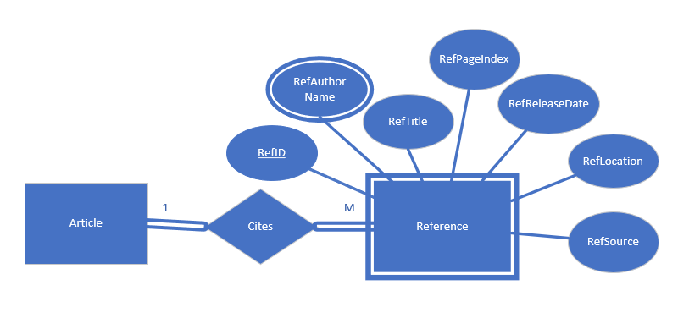An Article cites several References.

Figure 3: Reference EER Diagram

Block 4:

1. Event
2. Superclass
3. No superclasses
4. Conference
5. Every Event has a unique ID number (EventID), a start date (EvStartDate), end date (EvEndDate), name (EvName), location (EvLocation), point of contact (EvPointOfContact), and several sponsors (EvSponsor). The Point of Contact has a name (PCName), email (PCEmail), address (PCAddress), fax number (PCFax), and telephone number (PCTel).
6. 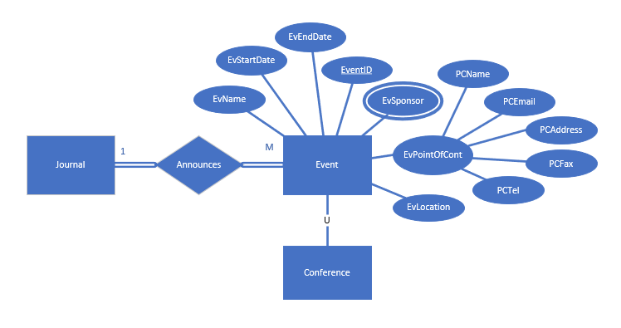A Journal announces several Events.

Figure 4: Event EER Diagram

Block 5:

1. Conference
2. Subclass
3. Event
4. No subclasses
5. A Conference has a coordinator (Coordinator), several guidelines (Guideline), several topics of interest (Topic), several conference paper submission dates (CPSDate), and several sets of paper contact information (CPSContInfo). Conference paper submission dates have a type (DateType) and a calendar date (CalDate). A paper contact information has a name (CPSName), type (CPSType), address (CPSAddress), email (CPSEmail), fax number (CPSFax), and telephone number (CPSTel).
6. 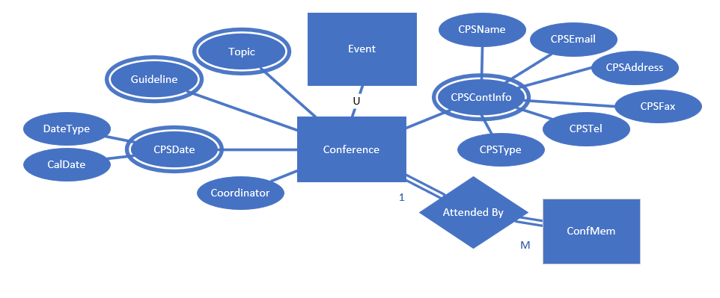A Conference is attended by several Conference Members.

Figure 5: Conference EER Diagram

Block 6:

1. ConfMem
2. Regular Entity
3. No superclasses
4. No subclasses
5. A Conference Member has a unique ID number (ConfMemID), a name (ConfMemName), type (ConfMemtype), affiliation (ConfMemAff), and country (ConfMemCountry).
6. 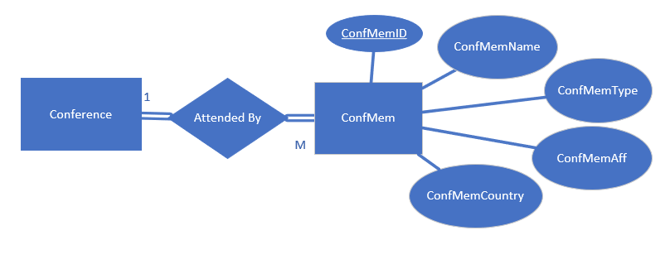A Conference is attended by several Conference Members.

Figure 6: Conference Member EER Diagram

Block 7:

1. JobList
2. Regular Entity
3. No superclasses
4. No subclasses
5. A Job Listing has a unique ID number (JobListID), an open date (JLOpenDate), close date (JLCloseDate), title (JLTitle), description (JLDescription), salary (JLSalary), status (JLStatus), location (JLLocation), employer (JLEmployer), set of contact information (JLContactInfo), several qualifications (JLQualification). Job Contact Information has a name (JLCInfoName), address (JLCInfoAddress), email (JLCInfoEmail), phone number (JLCInfoPhone), and fax number (JLCInfoFax).
6. 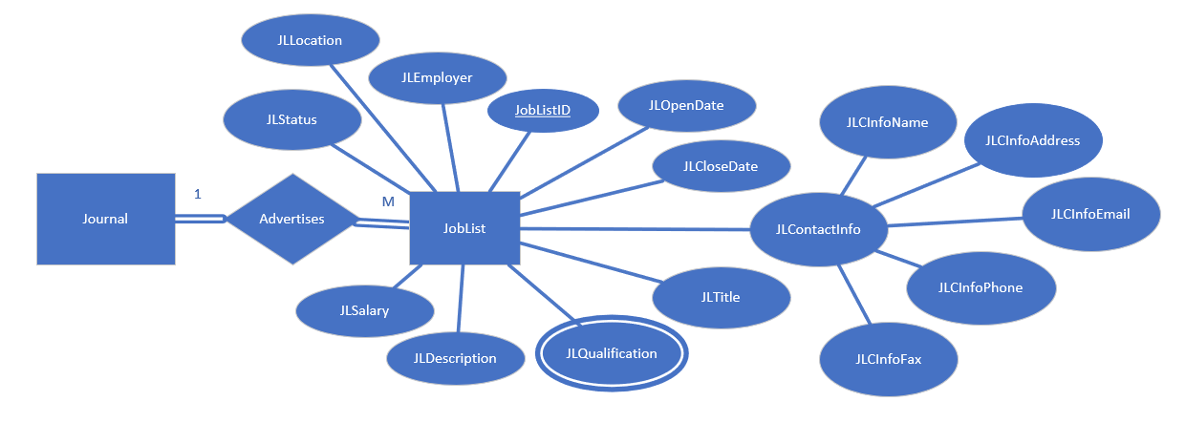A Journal advertises several Job Listings.

Figure 7: Job Listing EER Diagram

Block 8:

1. StuProfile
2. Regular Entity
3. No Superclasses
4. No Subclasses
5. A student profile has an ID (StuID), name (StuName), city (StuCity), state (StuState), country (StuCountry), backstory (StuBackstory), and several degrees (Degree).A degree has a degree level (DegLevel), completion year (DegComplete), and degree type (DegType).
6. 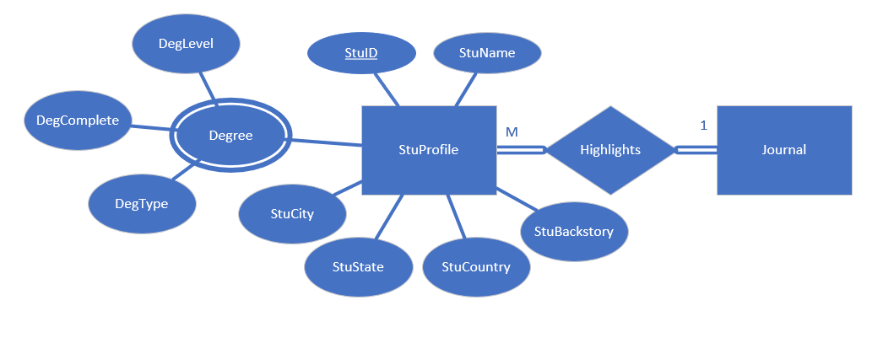A Journal highlights several Student Profiles.

Figure 8: Student Profile EER Diagram

## Table of Attributes

|  |  |  |
| --- | --- | --- |
| **Attribute Name** | **Attribute Description** | **Attribute Instance** |
| ArticleAbstract | The contents of an article’s Abstract section | The Monte-Carlo training paradigm… (full content of abstract) |
| ArticleAuthorAff | Affiliation of Author | University of Arkansas CSCI department |
| ArticleAuthorEmployer | Employer of Author | Google |
| ArticleAuthorName | Name of Author | John Robinson |
| ArticleContent | The body of the article | A neural network is composed of an input layer, one or more than one hidden layers and an output layer.... (full content of article body) |
| ArticleID | Unique ID of Article | 10012348 |
| ArticleKeyword | Keyword of the article | Prediction Power |
| ArticleTitle | Title of the article | Prediction Capabilities of Neural Networks Trained in Monte-Carlo Paradigm |
| CalDate | Conference Paper Submission Date | 2000-06-24 |
| ConfMemAff | Affiliation of a Member | SUNY at Stony Brook, USA |
| ConfMemCountry | Country of a Member | Japan |
| ConfMemID | Unique ID of Member | 52220186 |
| ConfMemName | Name of a Member | Larry Wittie |
| ConfMemType | Type of a Member | Program Chair |
| Coordinator | Coordinator of a Conference | Mary Johnson |
| CPSAddress | Conference contact address | 65 Red Ct. |
| CPSEmail | Conference contact | jane.green@gmail.com |
| CPSFax | Conference contact fax number | (875)912-5618 |
| CPSName | Conference contact name | Jane Green |
| CPSTel | Conference contact telephone number | (912)220-0641 |
| CPSType | Conference contact type | Paper Submission |
| DateType | Type of Conference Paper Submission Date | Abstract due |
| DegComplete | Year Degree completed | 2013 |
| DegLevel | Level of Degree | Masters |
| DegType | Field of Study | Economics |
| EvEndDate | End date of event | 1994-07-24 |
| EventID | Unique ID of event | 15382478 |
| EvLocation | Location of an Event | Madrid, Spain |
| EvName | Name of an Event | IFIP Congress 1992: 12th World Computer Congress |
| EvSponsor | Sponsor of an Event | International Federation for Information Processing |
| EvStartDate | Start date of event | 2015-07-04 |
| Guideline | Guidelines of Conference Paper Submission | At most 6000 words |
| IssDate | Date of Issue | 06/1992 |
| IssNum | Number of the Issue | 345 |
| JLCInfoAddress | Job Listing contact information address | 2 Blue Dr. |
| JLCInfoEmail | Job Listing contact email | john.smith@gmail.com |
| JLCInfoFax | Job Listing contact fax number | (912)523-1259 |
| JLCInfoName | Job Listing contact name | John Smith |
| JLCInfoPhone | Job Listing contact telephone number | (678)999-8212 |
| JLCloseDate | Job List close date | 2021-06-21 |
| JLDescription | Description of the Job | Tests new chicken products. |
| JLEmployer | Employer for a Job | Kentucky Fried Chicken |
| JLLocation | Location for a job | Kentucky, United States |
| JLOpenDate | Job List open date | 1992-02-01 |
| JLQualification | Qualification for a job | 5 years of experience |
| JLSalary | Salary of a job | $65,000 |
| JLStatus | Status of a job listing | Unfilled |
| JLTitle | Title of job position | Food Science Researcher |
| JobListID | Unique ID of a job listing | 35445599 |
| PCAddress | Event contact address | 41 Green Ave. |
| PCEmail | Event contact email | jane.smith@gmail.com |
| PCFax | Event contact fax number | (912)892-6254 |
| PCName | Event contact name | Jane Smith |
| PCTel | Event contact telephone number | (912)867-5309 |
| RefAuthorName | Reference author name | Michael Scott |
| RefID | Unique ID of Reference Entity | 60054254 |
| RefLocation | Location of a cited reference material | Cambridge, Massachusetts |
| RefPageIndex | Page index of a cited reference material | 145-156 |
| RefReleaseDate | Release date of a cited reference material | 1990-05-09 |
| RefSource | Source information of a reference | ACM Trans. Compute syst. |
| RefTitle | Title of a cited reference material | “Introduction to the Theory of Neural Computation” |
| StuBackstory | Student’s story | Wanted to be medical Doctor, dream came true at ASU. |
| StuCity | City the student lives in | Jacksonville |
| StuCountry | Country the student is from | Belgium |
| StuID | Unique Student ID | 90095444 |
| StuName | Name of a student | Bob Dole |
| StuState | State the student lives in | Alaska |
| Topic | Topics of Conference Paper Submission | Product modeling |
| VolNum | Number of the Volume | 5 |

# EER Diagram

Finalized EER Diagram created by putting together each entity’s individual diagrams.

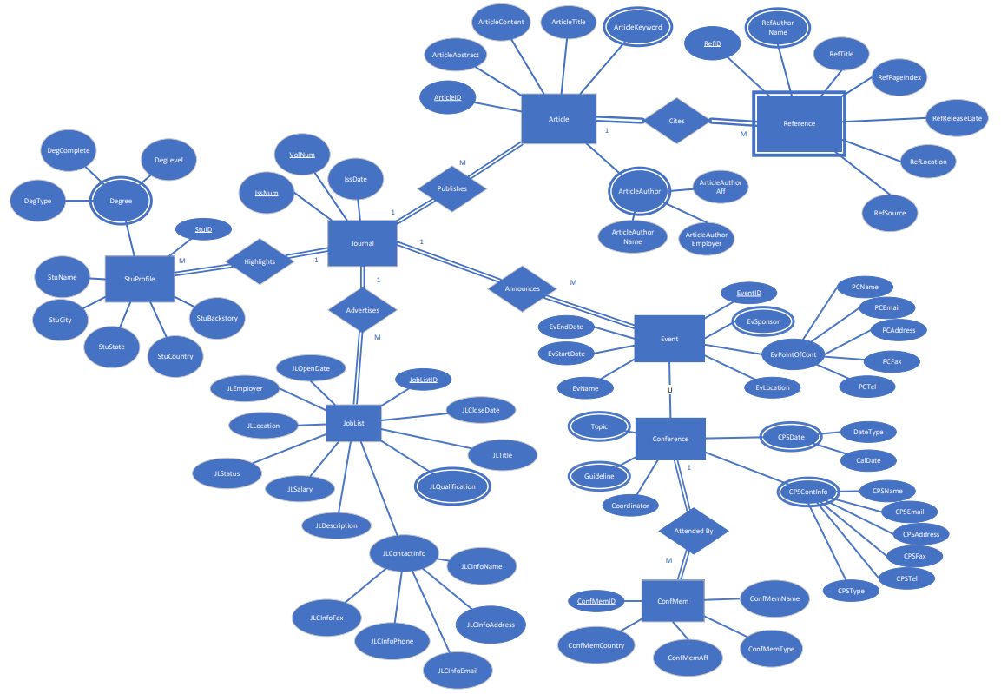

Figure 9: Complete EER Diagram

# Relational Schema

1. Journal(VolNum, IssNum, IssDate)
2. Article(ArticleID, VolNum, IssNum, ArticleTitle, ArticleContent, ArticleAbstract)
3. ArticleKeyword(ArticleID, ArticleKeyword)
4. ArticleAuthor(ArticleID, ArticleAuthorAff, ArticleAuthorName, ArticleAuthorEmployer)
5. Reference(RefID, ArticleID, RefTitle, RefPageIndex, RefReleaseDate, RefLocation, RefSource)
6. ReferenceAuthor(RefID, ArticleID, RefAuthorName)
7. Event(EventID, VolNum, IssNum, EvEndDate, EvStartDate, EvName, EvLocation, PCName, PCEmail, PCAddress, PCFax, PCTel)
8. EventSponsor(EventID, EvSponsor)
9. Conference(EventID, Coordinator)
10. ConferenceTopic(EventID, Topic)
11. ConferenceGuideline(EventID, Guideline)
12. CPSDate(EventID, DateType, CalDate)
13. CPSContInfo(EventID, CPSName, CPSEmail, CPSAddress, CPSFax, CPSTel, CPSType)
14. ConfMem(ConfMemID, EventID, ConfMemName, ConfMemType, ConfMemAff, ConfMemCountry)
15. JobList(JobListID, VolNum, IssNum, JLOpenDate, JLCloseDate, JLTitle, JLEmployer, JLLocation, JLStatus, JLSalary, JLDescription, JLCInfoName, JLCInfoAddress, JLCInfoEmail, JLCInfoPhone, JLCInfoFax)
16. Qualification(JobListID, JLQualification)
17. StuProfile(StuID, VolNum, IssNum, StuName, StuCity, StuState, StuCountry, StuBackstory)
18. Degree(StuID, DegType, DegComplete, DegLevel)

# Appendix

MINUTES OF THE MEETING

|  |  |  |
| --- | --- | --- |
| Date of Meeting: 4/17/21 | Start time: 7:00 pm | End time: 9:00 pm |

Name of members who were present:

Sam Wong

Jeel Patel

Hannah Jones

William Fletcher

Name of members who were late (the amount of time that member was late):

Members’ duty assignments, and progress made during meeting:

Creation of Blocks

|  |  |  |
| --- | --- | --- |
| Name: Sam Wong | Duty: | Progress: 100% |
| Name: Jeel Patel | Duty: | Progress: 100% |
| Name: Hannah Jones | Duty:  } | Progress: 100% |
| Name: William Fletcher | Duty: | Progress: 100% |

(any unfinished duties assigned to finish before next meeting)

Time set for the next meeting: 4/20/21, 6:30 pm

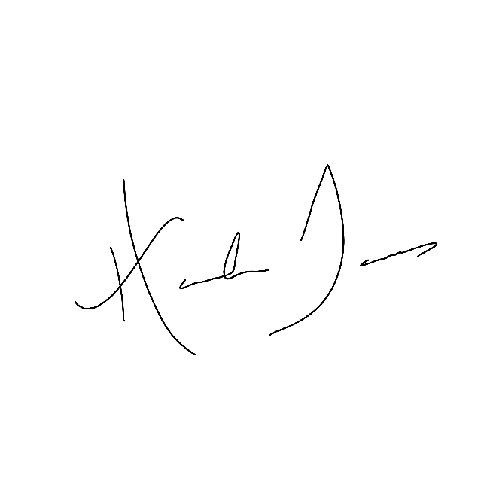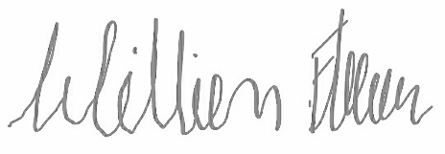Signature of all present members:

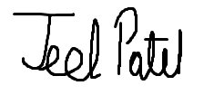

MINUTES OF THE MEETING

|  |  |  |
| --- | --- | --- |
| Date of Meeting: 4/20/21 | Start time: 6:30 pm | End time: 9:00 pm |

Name of members who were present:

Sam Wong

Jeel Patel

Hannah Jones

William Fletcher

Name of members who were late (the amount of time that member was late):

Members’ duty assignments, and progress made during meeting:

|  |  |  |
| --- | --- | --- |
| Name: Sam Wong | Duty: | Progress: 100% |
| Name: Jeel Patel | Duty: | Progress: 100% |
| Name: Hannah Jones | Duty:  } | Progress: 100% |
| Name: William Fletcher | Duty:  Blocks to EER Diagram | Progress: 100% |

(any unfinished duties assigned to finish before next meeting)

Time set for the next meeting: 4/24/21, 7:00 pm

Signature of all present members:



MINUTES OF THE MEETING

|  |  |  |
| --- | --- | --- |
| Date of Meeting: 4/24/21 | Start time: 7:00 pm | End time: 8:00 pm |

Name of members who were present:

Sam Wong

Jeel Patel

Hannah Jones

William Fletcher

Name of members who were late (the amount of time that member was late):

Members’ duty assignments, and progress made during meeting:

|  |  |  |
| --- | --- | --- |
| Name: Sam Wong | Duty: Formalize Minutes, Finalize  EER Diagram | Progress: 95% |
| Name: Jeel Patel | Duty: Complete and Proofread  Table of Attributes | Progress: 100% |
| Name: Hannah Jones | Duty: Formalize Report Document | Progress: 70% |
| Name: William Fletcher | Duty: Create Introduction | Progress: 50% |

(any unfinished duties assigned to finish before next meeting)

Time set for the next meeting: 4/27/21, 7:00 pm

Signature of all present members:

